GOVERNMENT OF INDIA
Ministry of Commerce & Industry | NICDC
Industrial Corridor Project Management System (IC-PMS)

MODULE 4
Cost Management &
Budget Control
GFR 2017 / PFMS / Primavera Unifier Aligned Financial Management
Detailed Design Document

Document Version: 1.0 | March 2026 | Classification: Restricted
Prepared by: IC-PMS Solution Architect Team | NICDC / Ministry of Commerce & Industry

1. Module Overview

1.1 Purpose & Objectives
Module 4 — Cost Management & Budget Control — is the financial spine of IC-PMS. It provides complete lifecycle financial control for India's industrial corridor construction programme, tracking every rupee from sanction through commitment, billing, deduction, payment, and final account settlement. The module is designed in full compliance with Government of India financial management regulations — specifically GFR 2017, CPWD Works Manual, CVC guidelines, and the Public Financial Management System (PFMS) operated by the Controller General of Accounts (CGA) — while drawing on the process architecture of Oracle Primavera Unifier's Cost Manager for its workflow and data model design.
The module operates as the financial truth layer of IC-PMS, integrating tightly with the WBS hierarchy (Module 1), the EVM engine (Module 2), and the satellite progress verification system (Module 3). This three-way integration creates a uniquely powerful control mechanism: no contractor invoice can be approved for PFMS payment unless it has passed a satellite-based progress verification gate, ensuring that public money flows only for work that has been physically verified by independent AI evidence.
Module 4 manages the entire financial lifecycle across all six national industrial corridors — from the initial DPR-derived budget estimate, through LOA issuance, Running Account Bill processing, Variation Order management, Revised Cost Estimate approval, contingency tracking, retention management, and final account — providing NICDC Finance, Ministry officials, and lenders with real-time financial intelligence at every level of the WBS hierarchy.

1.2 Module Scope
Capability | Included | Regulatory Reference
Budget hierarchy setup (WBS-linked, 8 levels) | Yes | GFR Rule 64 — Budget preparation
DPR estimate seeding of budget nodes | Yes | CPWD Works Manual — Estimate preparation
Commitment register (LOA / Work Order / PO) | Yes | GFR Rule 144 — Commitment accounting
Running Account Bill (RA Bill) processing | Yes | CPWD Works Manual Part I Chapter 6
Measurement Book (MB) digital certification | Yes | CPWD Works Manual — MB maintenance
Satellite progress gate for invoice approval | Yes | IC-PMS Extension — Module 3 integration
Deductions: Retention, Mobilisation Advance, LD | Yes | Contract conditions / GFR Rule 209
GST calculation and TDS deduction | Yes | GST Act 2017 / Income Tax Act Section 194C
PFMS integration for payment orders | Yes | PFMS API — CGA integration
Variation Order (VO) management and approval | Yes | GFR Rule 209 — Extra / Deviated items
Revised Cost Estimate (RCE) workflow | Yes | GFR Rule 64 — Revised estimate
Contingency tracking and WPI/CPI escalation | Yes | RBI index-linked price escalation clause
Cash flow S-curve (planned vs actual vs forecast) | Yes | Primavera Unifier Cost Sheet
EAC (Estimate at Completion) forecasting — 4 methods | Yes | ANSI/EIA-748 EVM / Primavera Unifier
Cost reporting (MPR, weekly flash, audit ledger) | Yes | CAG / Ministry reporting requirements

1.3 Key Design Principles
- PFMS-first payments: No payment can be released in IC-PMS without a corresponding PFMS payment order; IC-PMS acts as the pre-processing and approval layer, PFMS as the final payment authority
- Satellite gate mandatory: Every RA Bill must pass a Module 3 satellite progress verification check before entering the finance approval chain — contractor-claimed progress must be within 10% of AI-derived progress or a PMC override must be in place
- GFR 2017 compliance: All VO approval thresholds, commitment limits, advance payment rules, and retention percentages follow GFR 2017 and the standard CPWD/NIT conditions of contract
- Primavera Unifier data model: Budget hierarchy, commitment types, cost distribution, and forecast methods mirror Oracle Primavera Unifier's Cost Manager for data portability
- Immutable ledger: All financial transactions (budget, commitment, payment) are recorded in an append-only ledger; no transaction can be deleted — only reversed with an equal and opposite entry
- Four-eye approval: All financial approvals require at minimum two authorised signatories at the appropriate hierarchy level; dual-approval enforced by system workflow

2. Sub-Functions — Detailed Requirements

2.1 Sub-Function 4.1 — Budget Setup & Hierarchy
This sub-function establishes the complete budget architecture for each project — a hierarchical cost structure that mirrors the WBS from Module 1. Every WBS element that is a Work Package (leaf node) receives a budget node with a direct cost allocation; Summary WBS elements roll up automatically from their children.

Functional Requirements
- Budget hierarchy: Mirrors the 8-level WBS hierarchy from Module 1; budget nodes auto-created when WBS is published
- Budget seeding: DPR estimate values uploaded as structured Excel (line items by WBS code and cost category) or imported from Module 1 DPR document; system maps estimate lines to WBS budget nodes
- Cost categories: Each budget node has sub-budgets by cost category — Civil, Structural, MEP (Mechanical/Electrical/Plumbing), External Development, Roads & Pavement, Water & Sewerage, ICT, Social Infrastructure, Contingency, Price Escalation
- Contingency provisions: Configurable contingency % per WBS node (typically 5–10%); contingency drawn down through separate approval workflow when required
- Price escalation: WPI (Wholesale Price Index) and CPI (Consumer Price Index) linked provisions auto-calculated using RBI monthly indices; escalation credited to relevant WBS budget nodes
- Budget approval workflow: SPV CFO submits → NICDC Finance Director approves → Ministry note for total project cost above ₹500 Cr → CCEA for above ₹1,000 Cr
- Revised Cost Estimate (RCE): Formal revision workflow with mandatory: cause of revision, differential analysis vs. original DPR, escalation factors, approval at appropriate authority level
- Annual budget phasing: Total project budget phased across financial years (April–March); monthly sub-phasing within each FY for cash flow planning; phasing can be revised at SPV CFO level

Budget Categories & Sub-Budgets
Cost Category | Typical % of Package Value | GFR / CPWD Reference | Notes
Civil & Structural Works | 40–55% | CPWD SOR — Civil | Core construction; bid against BoQ
MEP Works | 12–18% | CPWD SOR — Electrical | Plumbing, electrical, HVAC, fire fighting
Road & Pavement | 8–15% | MoRTH Specifications | IRC standards; bituminous or concrete
Water Supply & Sewerage | 6–10% | CPHEEO Manual | Pipe, pump, treatment plant
ICT & Smart Infrastructure | 3–7% | MeitY standards | Fibre, CCTV, sensors, data centre
External Development | 5–10% | CPWD SOR | Landscaping, compound wall, gate
Contingency | 5–10% | GFR Rule 64 | Unforeseen items; separate approval to draw
Price Escalation Provision | 3–6% | RBI WPI/CPI | Auto-calculated monthly

2.2 Sub-Function 4.2 — Commitment Register
The Commitment Register records the financial obligations created when the government issues a Letter of Award (LOA), Work Order, Purchase Order, or Consultant Agreement. A commitment reduces the uncommitted budget and signals that a financial liability has been created — even before any work is done or invoice raised.

Commitment Types
Commitment Type | Trigger | GFR Rule | Approval Level
LOA (Letter of Award) | Contract award to successful EPC bidder | GFR Rule 149 / 154 | SPV Director (< ₹50 Cr); NICDC MD (₹50–500 Cr); Ministry (> ₹500 Cr)
Work Order | Sub-contract issued by main contractor | Contract Sub-letting clause | SPV PM approval; value < 25% of main LOA
Purchase Order (PO) | Procurement of materials / equipment | GFR Rule 149A / GeM Order | SPV CFO; direct PO against GeM
Consultant Agreement | PMC / DPR / Peer Review engagement | GFR Rule 148 | NICDC Finance Director
Variation Order (VO) Commitment | Approved VO added to LOA value | GFR Rule 209 | Tiered by VO value (see VO sub-function)
Advance Payment | Mobilisation / Material advance to contractor | GFR Rule 236 | Maximum 10% of LOA; Bank Guarantee mandatory

Functional Requirements
- Commitment creation: LOA, WO, PO entered in system by contract management team (Module 5 feeds commitment data); commitment amount linked to WBS budget node; available budget = Sanctioned Budget – Total Commitments
- Bank Guarantee (BG) tracking: Performance Security (typically 5% of LOA) and Advance Payment BG tracked in system with expiry date alerts (30, 15, 7 days before expiry)
- Retention: System automatically calculates and tracks retention deductions (typically 5% of each RA bill) until the retention release milestone (typically on DLP completion)
- Mobilisation advance: Advance payment tracked as a negative commitment; recovered through deductions from each subsequent RA bill at the agreed recovery rate
- Commitment vs. actuals: Real-time view of Committed Amount vs. Actuals Paid vs. Remaining to Bill for each contract
- Commitment expiry: LOAs expiring within 30 days flagged; extension workflow triggered if work still in progress

2.3 Sub-Function 4.3 — RA Bill & Invoice Management
This is the most operationally intensive sub-function in Module 4. The RA Bill (Running Account Bill) is the primary payment instrument in Indian government construction contracts — a periodic claim by the contractor for work done to date, measured, certified by the PMC, and approved through a defined financial approval chain before payment via PFMS.

RA Bill Processing Stages
- Contractor Bill Entry: EPC contractor submits RA Bill via IC-PMS portal or mobile app. Inputs: Bill Number, Bill Date, WBS Package, Gross Claimed Amount, % Physical Complete claimed, supporting documents (BOQ item-wise claimed quantities).
- Measurement Book (MB) Verification: PMC Site Engineer enters certified quantities from physical measurement into the digital MB. System computes MB-certified value and compares with contractor-claimed value. Discrepancies > 5% flagged for resolution.
- Satellite Progress Gate: System fetches the current AI-derived progress % from Module 3 for the WBS package. If |Contractor Claimed % – AI Progress %| > 10%, bill is held pending PMC review and resolution. PMC may override with field inspection evidence (see Module 3 rules).
- PMC Certification: PMC Resident Engineer formally certifies the bill — confirming: quantities, quality compliance (no outstanding NCRs), safety compliance, milestone adherence. Certification is digital with DSC/Aadhaar eSign.
- Deductions Calculation: System auto-computes all deductions: Mobilisation Advance Recovery (% per contract terms), Retention Money (5% standard), Liquidated Damages (LD) if applicable, Material Advance Recovery, any other contract deductions. Net Bill Value = Gross – Deductions.
- GST / TDS Processing: GST (18% standard; 12% for affordable housing components) computed on net bill value. TDS deducted at source as per Income Tax Act Section 194C (1% for individual/HUF; 2% for companies). System validates contractor GSTIN against GSTN portal.
- Financial Approval Workflow: Net payable amount goes through tiered financial approval — SPV Engineer → PMC → SPV Finance Manager → SPV CFO → NICDC Finance (if above threshold). Each approver has a configurable financial delegation of authority.
- PFMS Payment Order: On final approval, system generates a PFMS-compatible payment order (Digital Payment Advice — DPA) and transmits to PFMS via API. PFMS processes direct bank transfer to contractor's registered account. Payment confirmation received and recorded in D4 (Payment Log).

Delegation of Financial Authority — RA Bill Approval
Net Bill Value | Level 1 Approver | Level 2 Approver | Level 3 Approver
Up to ₹ 1 Cr | SPV Site Engineer | PMC Resident Engineer | —
₹ 1 Cr – ₹ 5 Cr | PMC RE | SPV Finance Manager | —
₹ 5 Cr – ₹ 20 Cr | SPV Finance Manager | SPV CFO | —
₹ 20 Cr – ₹ 50 Cr | SPV CFO | NICDC Finance Manager | —
Above ₹ 50 Cr | NICDC Finance Manager | NICDC Finance Director | Ministry concurrence note

2.4 Sub-Function 4.4 — PFMS Integration & Payment
The PFMS (Public Financial Management System) integration is the critical last-mile connection between IC-PMS's internal approval workflows and the Government of India's central treasury system. All payments on IC-PMS-managed projects flow through PFMS — ensuring full compliance with government fund management rules and enabling real-time fund utilisation tracking by the Controller General of Accounts (CGA).

Functional Requirements
- Payment order generation: On final IC-PMS approval, system auto-generates a Digital Payment Advice (DPA) with: Beneficiary name, Bank Account (validated against PFMS vendor master), IFSC code, Amount (with rupee and paise), Purpose code, DDO code, PAO code
- PFMS API transmission: DPA transmitted to PFMS via HTTPS REST API (OAuth 2.0); PFMS returns Transaction Reference Number (TRN) as acknowledgement
- Payment status tracking: System polls PFMS API for payment status (Pending / Processed / Failed / Returned); payment log updated in real-time; contractor notified via SMS/email on processing
- Fund availability check: Before DPA transmission, system queries PFMS for available balance in the relevant sanction head; insufficient funds flagged to NICDC Finance for supplementary grant request
- PFMS reconciliation: Monthly reconciliation between IC-PMS Payment Log (D4) and PFMS statement; discrepancies flagged for finance team investigation
- Failed payments: Failed/returned payments logged with reason code; re-submission workflow with corrected details before re-transmission to PFMS
- Advance payments: Mobilisation advance and material advance processed as separate PFMS transactions with Bank Guarantee linkage; recovery tracking auto-updated on each subsequent RA bill

2.5 Sub-Function 4.5 — Cost Forecasting & EAC
Cost forecasting provides NICDC Finance and Ministry officials with forward-looking estimates of total project cost at completion, enabling early identification of cost overruns and timely corrective action. IC-PMS implements four standard EAC forecasting methods (aligned with ANSI/EIA-748 and Primavera Unifier), plus an IC-PMS ensemble forecast.

EAC Forecasting Methods
Method | Formula | When to Use | Reliability
Method 1 — BAC / CPI | EAC = BAC / CPI | Default; assumes past cost efficiency continues | High — most commonly used in EVM
Method 2 — ACWP + ETC/CPI | EAC = ACWP + (BAC – BCWP) / CPI | When remaining work will continue at current efficiency | High for mature projects
Method 3 — ACWP + Remaining Budget | EAC = ACWP + (BAC – BCWP) | When current inefficiency is a one-time event | Optimistic — use with caution
Method 4 — Bottom-Up Roll-up | EAC = ACWP + Sum(ETC per work package) | When package-level re-estimates are available | Most accurate but effort-intensive
IC-PMS Ensemble | Weighted average of M1 (50%) + M4 (30%) + M2 (20%) | Default NICDC reporting EAC | Balanced; reduces single-method bias

Functional Requirements
- Auto-computation: EAC for all four methods computed automatically on each data date advance using current BCWP, ACWP, and BAC values from the EVM engine (Module 2)
- EAC trend tracking: Historical EAC values stored per data date to show whether forecast is improving or deteriorating — visible as EAC trend line on the forecast dashboard
- RCE trigger: If EAC (Method 1) exceeds BAC by > 5% for two consecutive data dates, system auto-generates a Revised Cost Estimate (RCE) initiation notification to SPV CFO
- What-if forecasting: Users can model 'what-if' scenarios — e.g., 'If CPI improves to 0.95 in Q3, what will EAC be?' — with results shown in a scenario comparison table
- Contingency drawdown forecast: System forecasts remaining contingency balance considering committed VOs and probabilistic VO pipeline, alerting when contingency is likely to be exhausted before project completion
- Price escalation forecast: WPI/CPI trends applied to remaining uncommitted budget to project total escalation liability for the project duration

2.6 Sub-Function 4.6 — Variation Order (VO) Management
Variation Orders arise when the scope of work under a contract needs to change — due to design modifications, unforeseen site conditions, quantity variations, or extra items not covered in the original BOQ. IC-PMS provides a full VO lifecycle management system aligned with GFR 2017 Rule 209 and CPWD Works Manual procedures.

VO Types
VO Type | Definition | GFR Limit | Approval Authority
Deviation (Quantity Change) | Increase or decrease in BOQ item quantity beyond ±25% | VO value ≤ 5% of LOA: SPV Director; 5–10%: NICDC | GFR Rule 209(1)
Extra Item | New item not in original BOQ; rates derived from DSR or market analysis | VO value ≤ 5% of LOA: SPV Director; 5–10%: NICDC | GFR Rule 209(2)
Substitution | Replace one material/method with another equivalent; must be cost-neutral or cheaper | Any value: SPV Director with PMC recommendation | CPWD Works Manual
Omission | Delete a BOQ item entirely; reduces contract value | Any value: SPV Director | Contract conditions
Emergency VO | Urgent work required to prevent danger to life/property; post-facto approval | Limited to emergency; post-facto within 7 days | NICDC MD approval
Design Change VO | Change in engineering design with cost impact; requires Proof Consultant review | > 5% LOA: NICDC; > 10%: Ministry concurrence | GFR Rule 209 + CVC guidelines

Functional Requirements
- VO register: All VOs for all contracts logged in D6 with: VO number, Type, Description, BOQ item reference, Quantity change, Rate justification, VO value, Running total as % of LOA value
- GFR 10% ceiling: System tracks cumulative VO value as % of LOA for each contract; alert at 8% (approaching limit); hard stop with Ministry approval workflow at 10%
- Rate justification: Extra item rates must be supported by: DSR 2024-25 analysis, Market rate analysis (3 quotations minimum), or Contractor-quoted rate with PMC recommendation
- VO impact analysis: Before submission for approval, system computes impact on: budget (uncommitted balance), schedule (Module 2 EVM float impact), and overall EAC
- VO approval workflow: Tiered by VO value and type; all approvals tracked with timestamp and digital signature; rejected VOs returned with reason code
- Cumulative VO analytics: Dashboard showing total VO value by package, by type, trend over time — enabling NICDC to identify which packages are experiencing scope instability

2.7 Sub-Function 4.7 — Cash Flow Analytics
Cash flow analytics provides time-phased financial planning and monitoring — the ability to see not just total budget but how much money needs to flow in each month, compare it against what actually flowed, and forecast future cash requirements based on current progress and EAC.

Functional Requirements
- S-curve generation: Cumulative planned vs. actual vs. forecast cash flow chart (₹ Cr per month and cumulative) at project, node, package, and programme levels
- Monthly cash flow planning: Budget phased to monthly level based on linked schedule; actual cash flow updated on each PFMS payment confirmation
- Forecast cash flow: Based on EAC and current schedule, system projects monthly cash requirements for the remainder of the project — enabling NICDC Finance to plan fund releases
- Annual budget vs. actuals: Monthly comparison of annual budget allocation (released by Ministry) vs. actual expenditure; alert if spending pace puts annual budget at risk (under-spend or over-spend vs. allocation)
- Pending bills ageing: Bills in queue analysed by days pending at each approval stage; alerts for bills pending > 30 days (GFR timely payment obligation)
- Fund utilisation report: Real-time fund utilisation by WBS node, cost head, and financial year for NICDC Finance, Ministry, and CAG reporting
- Cash flow scenarios: What-if modelling for accelerated/decelerated construction scenarios — showing impact on monthly cash requirements under each scenario

2.8 Sub-Function 4.8 — Cost Reporting
The Cost Reporting sub-function auto-generates all mandatory financial reports required by NICDC governance, Ministry oversight, lender covenants, and CAG audit — pulling data from the cost ledger, payment log, and EVM engine to produce accurate, formatted, and distribution-ready outputs.

Standard Cost Reports
Report Name | Frequency | Audience | Key Content
Monthly Financial Progress Report (MFPR) | Monthly (5th of month) | NICDC Finance / Ministry | Fund utilisation, EAC vs. BAC, VO status, pending bills, cash flow S-curve, RCE status
Weekly Payment Status Flash | Weekly (Monday) | SPV CFO / PMC | Bills pending, PFMS queue status, payments made in week, aged bills > 14 days
Annual Fund Utilisation Report | Annually (March 31) | Ministry / CAG / CGA | Financial year expenditure vs. allocation by project and head of account; PFMS reconciliation
EAC Forecast Report | Monthly with MFPR | Lenders / Ministry | All four EAC methods, ensemble EAC, trend chart, package-level breakdown, contingency balance
VO Register Report | Monthly | NICDC Finance / Legal | All VOs by package — type, value, status, cumulative %, GFR headroom
Audit Trail Report | On demand / Annually | CAG / Internal Audit | Complete financial ledger — every budget entry, commitment, deduction, payment; with user, timestamp, PFMS ref
Retention & BG Expiry Report | Monthly | SPV Finance / Legal | All pending retention releases, BG expiry dates within 60 days, advance recovery balance
Cost Overrun Early Warning | Automatic (weekly) | NICDC Finance Director | Packages where EAC > BAC + 5%; CPI < 0.90; contingency < 20% remaining

3. Data Flow Diagrams

3.1 DFD Level 0 — Context Diagram
The Context Diagram shows Module 4 as the Cost Management Engine (Process 4.0) receiving budget parameters from Module 1, EVM metrics from Module 2, RA Bills from contractors, fund releases from PFMS, and LOA/VO values from Module 5. It feeds payment data back to PFMS, cost actuals to Module 2, and financial reports to NICDC Finance and Ministry.
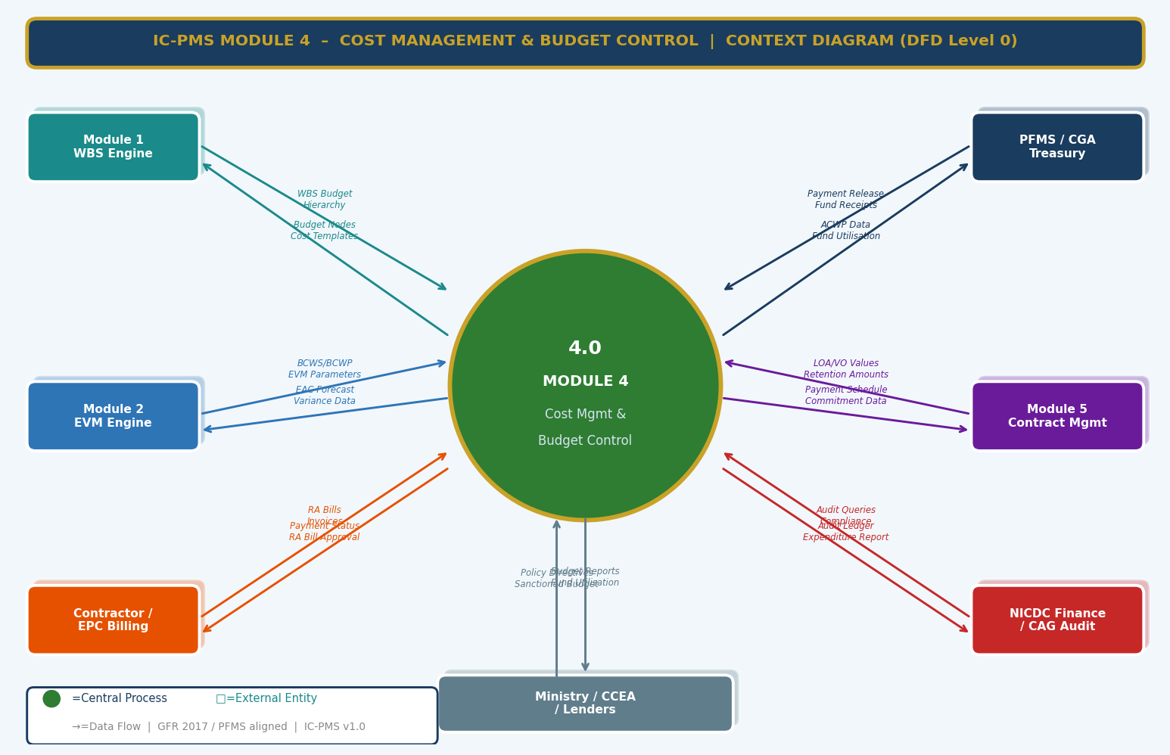
Figure 3.1 — DFD Level 0: Module 4 Context Diagram (PFMS, WBS, EVM, Contractor, Ministry Flows)

External Entity Data Flow Summary
External Entity | Inputs to Module 4 | Outputs from Module 4
Module 1 — WBS Engine | WBS budget hierarchy, DPR estimate values, cost templates per asset type | Budget nodes seeded in cost ledger, Cost confirmation per WBS element
PFMS / CGA Treasury | Fund release confirmations, Payment processing status, Failed payment reason codes | Digital Payment Advice (DPA) for each approved invoice, PFMS payment order
Module 2 — EVM Engine | BCWS (time-phased budget), BCWP (earned value), EVM data date | ACWP (actual cost from invoices), EAC forecast, Cost variance reports
Module 5 — Contract Mgmt | LOA values, VO approvals, Advance payment amounts, Retention release milestones | Payment schedule, Commitment data, VO budget impact, Pending deductions
EPC Contractor / Billing | RA Bills (gross amount, BOQ claims, % complete), Advance payment requests | Payment status, Deduction statements, Net payable, PFMS payment reference
NICDC Finance / CAG Audit | Audit queries, Compliance requirements, Ministry financial ceilings | Financial audit reports, Expenditure statements, PFMS reconciliation, Ledger exports
Ministry / CCEA / Lenders | Sanctioned budget allocations, Policy directives, Loan disbursement conditions | Fund utilisation reports, EAC forecasts, Milestone payment certificates for lenders

3.2 DFD Level 1 — Main Processes & Data Stores
The Level 1 DFD shows eight core cost management processes feeding eight data stores. The pipeline flows from budget setup through commitment, billing, payment, and then branches into forecasting, VO management, cash flow analytics, and reporting.
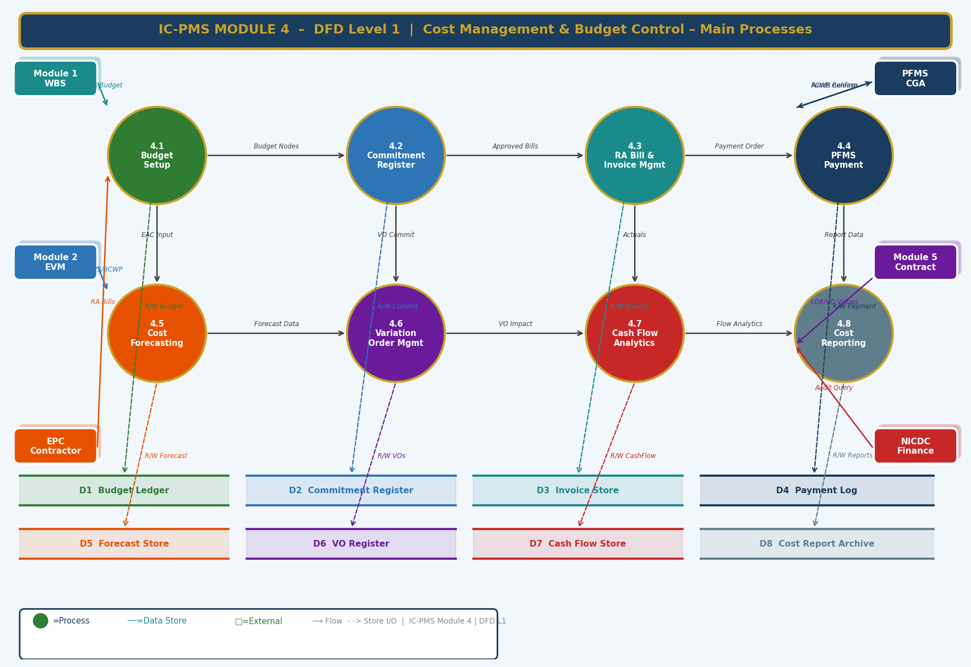
Figure 3.2 — DFD Level 1: Eight Core Processes and Eight Data Stores

Process & Data Store Summary
ID | Name | Primary Function | Key Stores
4.1 | Budget Setup | Establishes WBS-linked budget hierarchy; seeds from DPR; manages RCE workflow | D1 Budget Ledger
4.2 | Commitment Register | Records LOA/WO/PO/VO commitments; tracks BG and advance; manages retention | D2 Commitment Register
4.3 | RA Bill & Invoice Mgmt | Processes contractor bills through MB verify, satellite gate, PMC cert, deductions, GST/TDS | D3 Invoice Store, D9 MB Register, D10 Deduction Log
4.4 | PFMS Payment | Generates DPA, transmits to PFMS API, tracks payment status, handles reconciliation | D4 Payment Log
4.5 | Cost Forecasting | Computes EAC (4 methods + ensemble), contingency forecast, price escalation projection | D5 Forecast Store
4.6 | VO Management | Manages VO lifecycle — initiation, rate justification, approval, budget impact, GFR ceiling tracking | D6 VO Register
4.7 | Cash Flow Analytics | Generates S-curves, monthly plan vs. actual, forecast cash requirements, aged bills analysis | D7 Cash Flow Store
4.8 | Cost Reporting | Auto-generates MFPR, audit trail, VO register, EAC report, retention/BG expiry report | D8 Report Archive

3.3 DFD Level 2 — Process 4.3: RA Bill & Invoice Management (Exploded)
The Level 2 DFD drills into the most complex and operationally critical process in Module 4 — the RA Bill workflow. It shows all eight sub-processes from contractor bill entry through MB verification, satellite gate, PMC certification, deductions, GST/TDS processing, approval workflow, and PFMS payment order generation, including the satellite progress gate decision diamond.
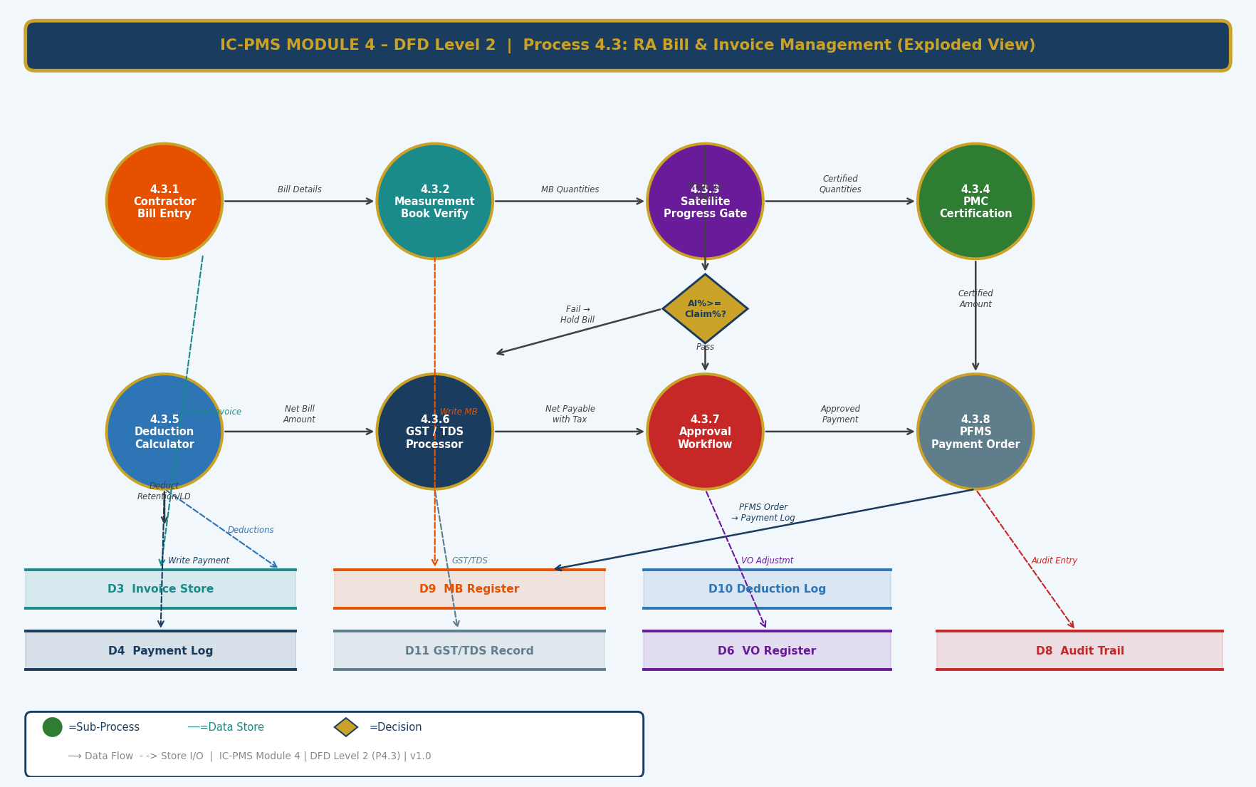
Figure 3.3 — DFD Level 2: Process 4.3 RA Bill Management — 8 Sub-Processes with Satellite Gate Decision

Sub-Process Narrative
Sub-Process | Name | Description
4.3.1 | Contractor Bill Entry | EPC contractor submits RA Bill via IC-PMS portal: Bill number, date, WBS package, BOQ item-wise quantities claimed, gross amount, % physical complete claimed, supporting documents. System creates invoice record in D3 with status = Submitted.
4.3.2 | Measurement Book Verification | PMC Site Engineer enters field-measured quantities item-by-item in the digital MB (D9). System computes MB-certified value and flags discrepancy if > 5% vs. contractor claim. Measurement book entry requires PMC Engineer DSC/Aadhaar eSign. MB-certified amount updates the invoice record.
4.3.3 | Satellite Progress Gate | System fetches AI-derived progress % from Module 3 (D4 of Module 3 — Satellite Progress Record) for the WBS package at current data date. Compares with contractor-claimed %. If |AI% – Claim%| > 10%: invoice HELD; PMC alert raised. PMC can override with field evidence. Gate decision writes PASS/HOLD to invoice record.
4.3.4 | PMC Certification | PMC Resident Engineer reviews MB quantities, satellite gate result, quality compliance (NCR status), and safety compliance. Formally certifies the bill — amount, deductions applicable, and recommended net payment. Certification recorded with DSC timestamp. Certified amount enters deductions calculator.
4.3.5 | Deductions Calculator | System auto-computes all applicable deductions from certified gross amount: Mobilisation Advance Recovery (per contract recovery schedule), Retention Money (5% standard per bill), Liquidated Damages (if delay exists and LD not waived), Material Advance Recovery, Other contract deductions. Net Bill = Gross – Sum(Deductions). Deduction records written to D10.
4.3.6 | GST / TDS Processor | GST (18% standard; 12% for specified works) computed on net bill value. TDS deducted at 2% (corporate) per Income Tax Act Section 194C. System validates contractor GSTIN against GSTN API (D11). Net payable = Net Bill + GST – TDS. GST/TDS record written to D11.
4.3.7 | Approval Workflow | Net payable amount routed through tiered approval chain based on amount (see delegation matrix in Section 2.3). Each approver reviews all bill details, deductions, and satellite evidence. System enforces sequential approval; parallel approval not permitted. Time-stamped approval records written to D3.
4.3.8 | PFMS Payment Order | On final approval, system generates PFMS Digital Payment Advice (DPA): beneficiary details, validated bank account, amount, purpose code, DDO/PAO codes. DPA transmitted to PFMS REST API. PFMS Transaction Reference Number received and stored. Payment status polled and recorded in D4 (Payment Log). Audit entry written to D8.

4. Master Data Model

4.1 Entity Relationship Overview
The Module 4 master data model contains twelve core financial entities. The Budget Ledger is the root entity; the Commitment Register, Invoice, and Payment Log form the operational financial pipeline. The Deduction Ledger, GST/TDS Record, VO Register, and Retention Register are supporting entities that ensure complete auditability of every financial transaction.
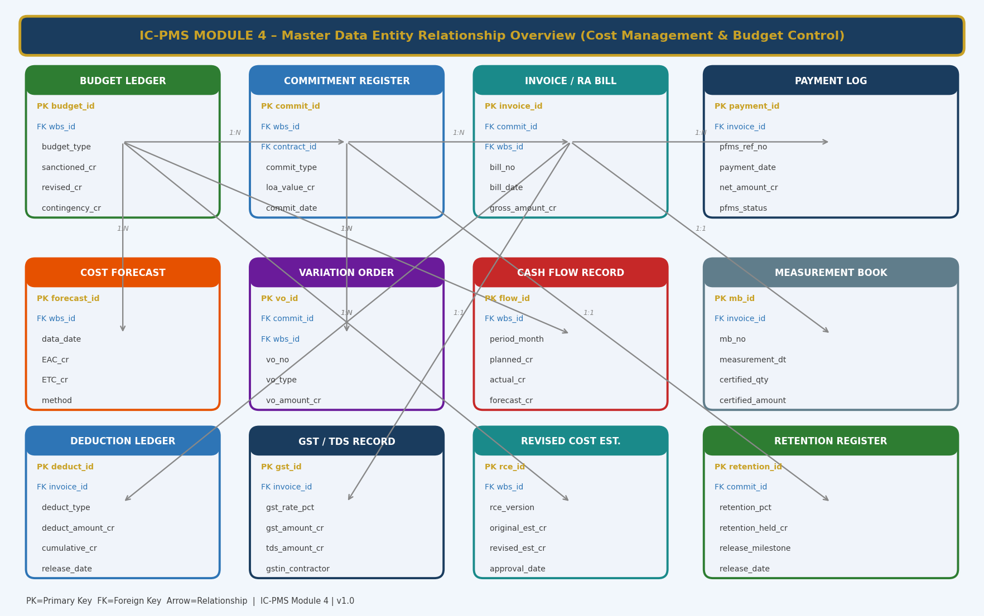
Figure 4.1 — Master Data Entity Relationship Overview (Module 4 — Cost Management & Budget Control)

4.2 Core Entity Field Definitions

4.2.1 Budget Ledger
budget_id | UUID — Primary Key
wbs_id | FK → Module 1 WBS Element — one budget node per WBS element
budget_type | ENUM: Original_DPR / Revised_RCE_v1 / Revised_RCE_v2 / Current_Approved
sanctioned_cr | DECIMAL(15,2) — total approved budget for this WBS element in INR Crore
revised_cr | DECIMAL(15,2) — budget after approved RCE; NULL if no revision
contingency_cr | DECIMAL(15,2) — contingency provision; managed as separate sub-ledger
escalation_cr | DECIMAL(15,2) — price escalation provision; auto-updated monthly using WPI/CPI
annual_phasing_json | JSONB — {'FY2025-26': 280.5, 'FY2026-27': 420.0, ...} phasing by financial year
committed_cr | DECIMAL(15,2) — computed: sum of all active commitments against this WBS
actual_cr | DECIMAL(15,2) — computed: sum of all approved payments against this WBS
forecast_cr | DECIMAL(15,2) — EAC from Module 2 EVM engine
budget_status | ENUM: Draft / Submitted / Approved / Active / Under_Revision
approved_by | FK → User — Finance authority who approved the budget
approval_date | DATE — date of budget approval

4.2.2 Commitment Register
commit_id | UUID — Primary Key
wbs_id | FK → WBS Element — the work scope the commitment covers
contract_id | FK → Module 5 Contract Master — the contract this commitment stems from
commit_type | ENUM: LOA / Work_Order / Purchase_Order / Consultant_Agreement / VO_Commitment / Advance_Payment
loa_value_cr | DECIMAL(15,2) — original LOA/contract value
current_value_cr | DECIMAL(15,2) — LOA value + all approved VOs to date
committed_date | DATE — date of LOA/WO issuance
contractor_id | FK → Organisation Master — the contracted party
advance_paid_cr | DECIMAL(15,2) — mobilisation/material advance paid to date
advance_recovered_cr | DECIMAL(15,2) — advance recovered through RA Bill deductions to date
retention_held_cr | DECIMAL(15,2) — cumulative retention deducted from bills to date
bg_performance_ref | VARCHAR — Performance Security BG reference number
bg_expiry_date | DATE — PBG expiry; system alert 30/15/7 days before
commit_status | ENUM: Active / Partially_Billed / Fully_Billed / Closed / Terminated

4.2.3 Invoice / RA Bill
invoice_id | UUID — Primary Key
commit_id | FK → Commitment Register — the LOA this bill is against
wbs_id | FK → WBS Element — the work package billed
bill_no | VARCHAR — contractor-assigned bill number (e.g. RAB-005)
bill_date | DATE — date of contractor submission
bill_type | ENUM: Running_Account / Final_Bill / Advance_Payment / Material_Advance
gross_amount_cr | DECIMAL(15,2) — contractor-claimed gross amount
mb_certified_amount_cr | DECIMAL(15,2) — PMC measurement book certified amount
satellite_ai_pct | DECIMAL(5,2) — AI-derived progress at bill date (from Module 3)
contractor_pct | DECIMAL(5,2) — contractor-claimed physical % complete
satellite_gate_status | ENUM: Passed / Held / Override_Approved
pmc_certified_amount_cr | DECIMAL(15,2) — final PMC certified payable amount
net_payable_cr | DECIMAL(15,2) — gross – deductions + GST – TDS
invoice_status | ENUM: Submitted / MB_Verify / Satellite_Gate / PMC_Cert / Deductions / GST_TDS / Approval / PFMS_Pending / Paid / Rejected
current_approver_id | FK → User — person currently holding the approval
age_days | INTEGER — computed: days since submission

4.2.4 Payment Log
payment_id | UUID — Primary Key
invoice_id | FK → Invoice / RA Bill
pfms_ref_no | VARCHAR — PFMS Transaction Reference Number (TRN)
payment_date | DATE — date payment was processed by PFMS
net_amount_cr | DECIMAL(15,2) — actual amount remitted to contractor
beneficiary_account | VARCHAR(20) — masked bank account number (last 4 digits visible)
ifsc_code | VARCHAR(11) — validated IFSC code
pfms_status | ENUM: DPA_Generated / Transmitted / Processed / Failed / Returned / Reconciled
payment_mode | ENUM: RTGS / NEFT / IMPS — determined by amount and urgency
head_of_account | VARCHAR — PFMS Major/Sub-Major/Minor head of account
ddo_code | VARCHAR — Drawing and Disbursing Officer code
pao_code | VARCHAR — Principal Accounts Office code
failure_reason | VARCHAR — populated if pfms_status = Failed / Returned
reconciled_date | DATE — date reconciled with PFMS statement; NULL if pending

4.2.5 Variation Order
vo_id | UUID — Primary Key
commit_id | FK → Commitment Register — the LOA this VO modifies
wbs_id | FK → WBS Element — scope of the variation
vo_no | VARCHAR — sequential VO number (e.g. VO-042)
vo_type | ENUM: Deviation / Extra_Item / Substitution / Omission / Emergency / Design_Change
description | TEXT — detailed description of the variation
original_boa_ref | VARCHAR — original BOQ item reference (for Deviation type)
vo_quantity | DECIMAL — quantity variation (positive = increase, negative = decrease)
vo_rate_cr | DECIMAL(15,2) — rate per unit (from DSR / Market / Contractor quote)
vo_amount_cr | DECIMAL(15,2) — total VO value = quantity × rate
cumulative_vo_pct | DECIMAL(5,2) — computed: cumulative VO value as % of LOA — critical for GFR 10% ceiling
rate_justification | TEXT — DSR item ref, market analysis summary, or PMC recommendation
vo_status | ENUM: Draft / Submitted / PMC_Recommended / SPV_Approved / NICDC_Approved / Ministry_Approved / Rejected
approval_date | DATE
gfr_ceiling_flag | BOOLEAN — true if this VO would cause cumulative VO% to exceed 10%

4.2.6 Revised Cost Estimate (RCE)
rce_id | UUID — Primary Key
wbs_id | FK → WBS Element (typically project level)
rce_version | VARCHAR — e.g. RCE-01, RCE-02
original_est_cr | DECIMAL(15,2) — original DPR estimate value
revised_est_cr | DECIMAL(15,2) — revised total project cost estimate
variance_cr | DECIMAL(15,2) — revised_est_cr – original_est_cr
variance_pct | DECIMAL(5,2) — variance as % of original estimate
cause_of_revision | TEXT — mandatory explanation of cost increase causes
escalation_component_cr | DECIMAL(15,2) — amount attributable to WPI/CPI escalation
scope_change_component_cr | DECIMAL(15,2) — amount attributable to scope additions
design_change_component_cr | DECIMAL(15,2) — amount attributable to design revisions
approval_date | DATE
approved_by | FK → User — Ministry / NICDC authority
ccea_note_required | BOOLEAN — true if variance > 20% or absolute > ₹1,000 Cr

5. UI/UX Screen Designs
Module 4 delivers five primary screens covering the main financial management workflows. The design maintains consistency with Modules 1–3 — dark navy sidebar, gold accents, green as the Module 4 identity colour (representing money/finance). Financial figures are displayed in Indian numbering format (₹ Cr) throughout. All screens support role-based data visibility — contractors see only their own financial data; NICDC Finance sees all corridors; SPV Finance sees their node only.

Screen 1 — Budget Dashboard
The Budget Dashboard is the financial health overview screen for NICDC Finance, SPV CFOs, and Ministry officials. It shows the four key financial metrics (Budget, Committed, Actual, EAC) as headline KPI cards, a package-level budget vs. committed vs. actual bar chart, a fund utilisation by cost head panel, and a live pending RA Bills queue.
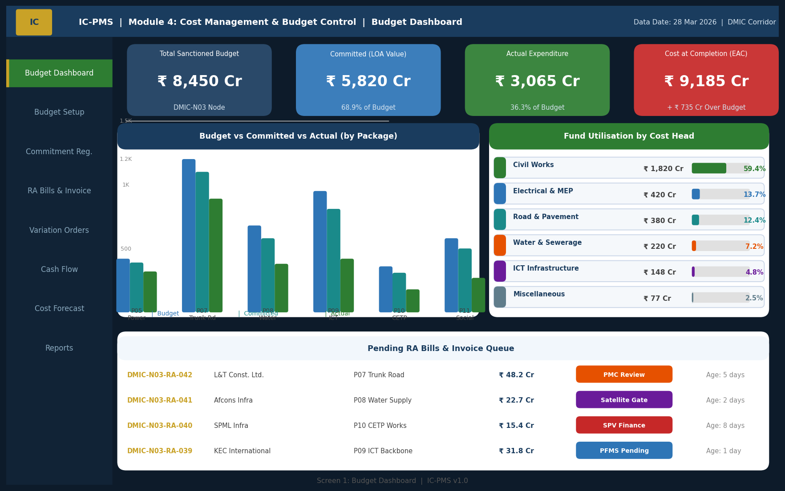
Figure 5.1 — Budget Dashboard (KPI Cards, Budget vs. Actual Chart, Cost Head Utilisation, Pending Bills Queue)

Dashboard UI Components
Component | Description | Interaction
KPI Cards (4 — top row) | Total Sanctioned Budget, Committed (LOA Value), Actual Expenditure, EAC — with colour coding and reference values. Navy=Budget, Blue=Committed, Green=Actual, Red=EAC if over Budget. | Click any card to drill into that metric's detail screen
Budget vs. Committed vs. Actual (bar chart) | Grouped bar chart per package showing 3 bars: Budget (blue), Committed (teal), Actual (green). Y-axis in ₹ Cr. | Click a package bar group to navigate to that package's financial detail
Fund Utilisation by Cost Head | Horizontal bar list showing each cost head with value and % of total expenditure. Coloured left stripe per head. | Click a cost head to see transaction-level breakdown
Pending Bills Queue | Tabular list of bills in approval pipeline with contractor, package, amount, current stage, and age. Age column colour-coded: Green <7d, Orange 7–30d, Red >30d. | Click a bill row to open the RA Bill processing screen (Screen 2)
Navigation Sidebar | 8 links for Module 4 functions; active screen highlighted green with gold stripe | Standard IC-PMS navigation pattern

Screen 2 — RA Bill & Invoice Processing
The RA Bill screen is the most operationally complex screen in Module 4. It shows the 8-step workflow as a progress stepper at the top, a bill header form, a deductions calculation panel, and the satellite progress gate evidence panel — all in a single scrollable view. The screen is used daily by PMC engineers and SPV finance staff.
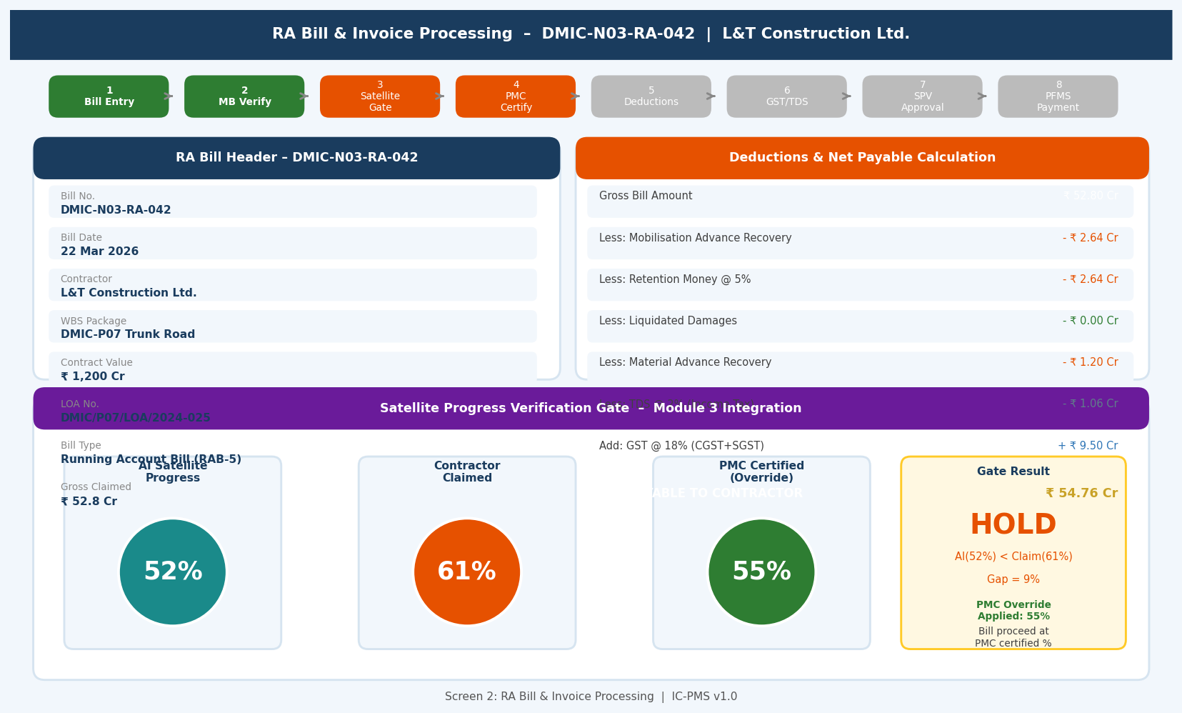
Figure 5.2 — RA Bill Processing Screen (Workflow Stepper, Bill Header, Deductions Panel, Satellite Gate Evidence)

RA Bill Screen UX Design Decisions
- Workflow stepper: 8 numbered steps shown as a horizontal progress bar at the top — completed steps in green, current step in orange, future steps in grey. Users cannot skip steps.
- Deductions panel: Right column shows a running 'bill calculator' where every deduction is shown as a line item reducing from gross to net — mimicking the physical 'abstract of bill' document familiar to PMC engineers
- Satellite gate panel: Fixed at the bottom of the screen — shows three circular progress dials (AI Satellite, Contractor Claimed, PMC Certified) with colour coding, enabling instant visual comparison of the three progress sources
- Gate result badge: Prominently displayed — PASS (green) or HOLD (orange) — with the gap percentage and override status clearly stated
- Approver action bar: For the current approver, an action bar appears at the bottom: Approve / Reject / Return for Correction — with mandatory comment field for Reject/Return
- Timeline: Collapsible timeline panel showing all actions taken on the bill with actor, timestamp, and comment — full audit trail visible at any stage

Screen 3 — Cash Flow S-Curve Analytics
The Cash Flow screen is the temporal financial view — showing the complete planned, actual, and forecast cash flow over the project lifecycle as both a cumulative S-curve and monthly bar chart. The screen is the primary tool for NICDC Finance's monthly fund planning and Ministry's budget release decisions.
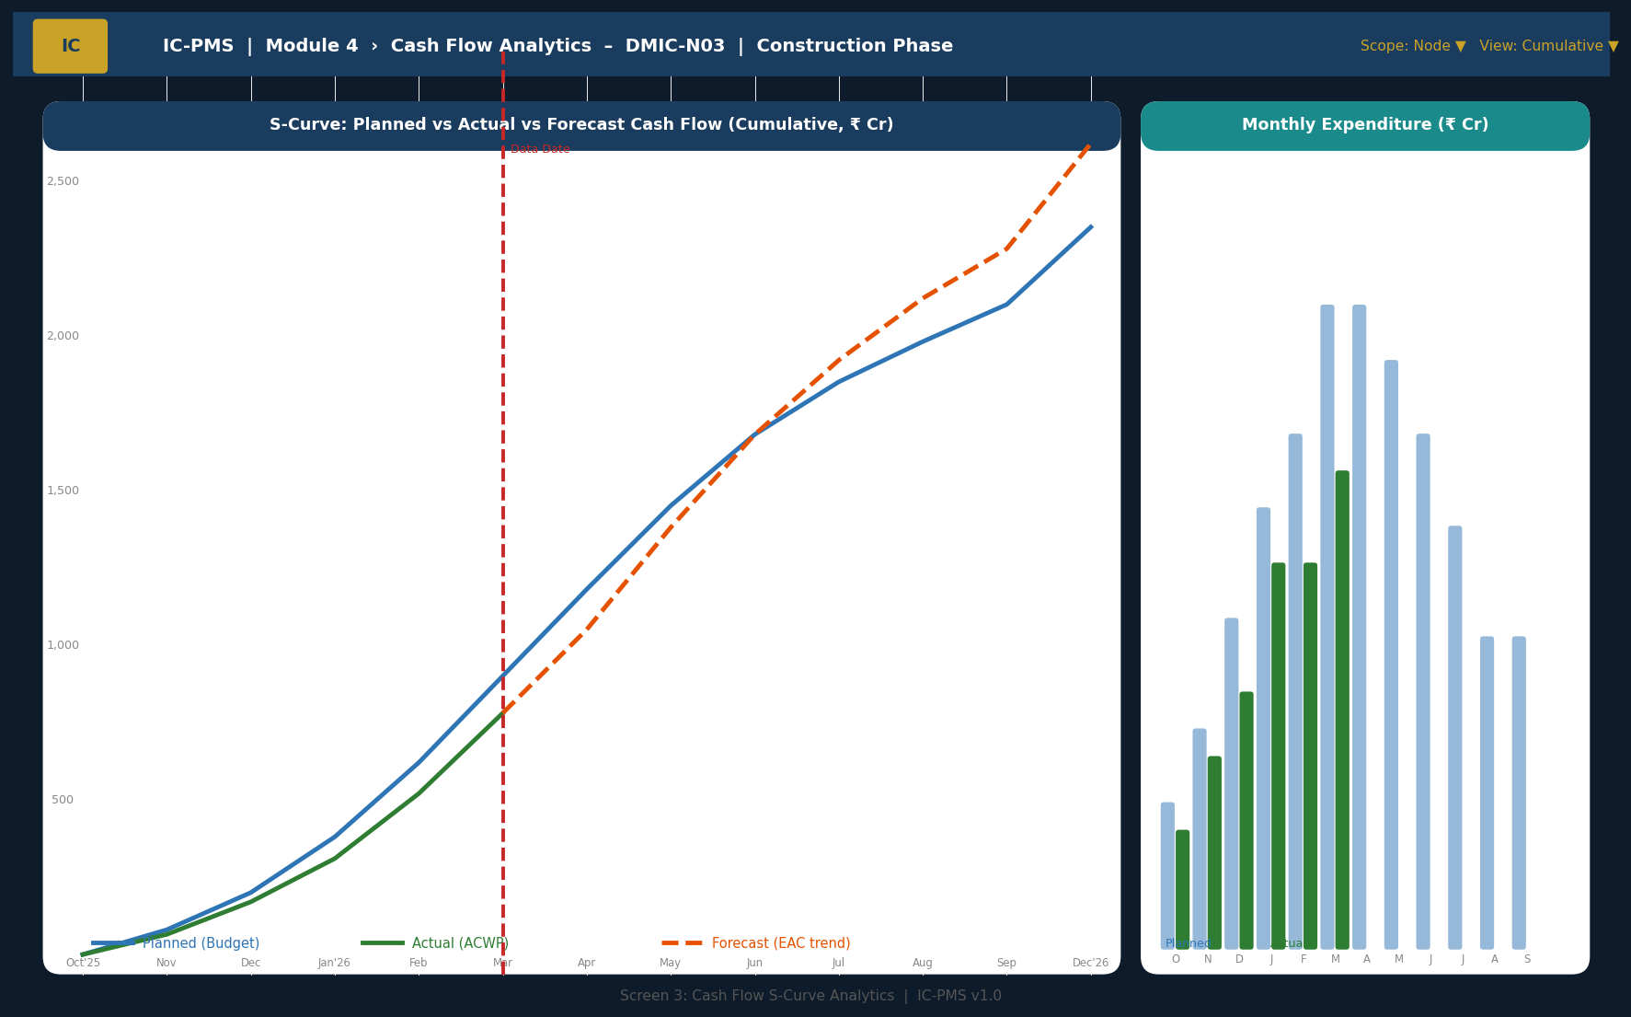
Figure 5.3 — Cash Flow S-Curve Analytics (Cumulative S-Curve, Monthly Bar Chart, Data Date Marker, Variance Shading)

Cash Flow Screen UI Features
Feature | Description
Cumulative S-curve | Three lines: Planned (blue), Actual (green), Forecast (orange dashed). Shaded red area between planned and actual = schedule variance in financial terms.
Data date vertical line | Red dashed vertical line marking today — separates historical actual data from forecast. Always visible even when scrolling.
Monthly bar chart (right panel) | Side-by-side monthly bars for planned vs. actual expenditure. Enables identification of months with under-spend or over-spend against allocation.
Scope selector | Switch between Programme/Corridor/Node/Package level; period selector for YTD/FY/Lifetime
Hover tooltip | Hover on any point of S-curve or bar to see exact planned, actual, and forecast values for that month in INR Crore
Export options | Export chart as PNG; data as Excel; full cash flow table as PDF for Ministry submission

Screen 4 — Variation Order Register
The VO Register screen provides a complete view of all variation orders across the selected scope — filterable by status, type, and package. The alert system for GFR 10% ceiling compliance is prominently featured. The detail panel at the bottom shows the full VO justification, approval chain, and budget impact.
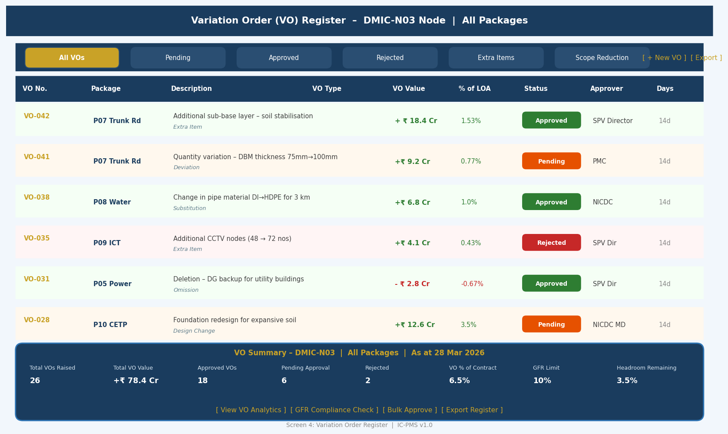
Figure 5.4 — Variation Order Register (VO Table, Status Filters, GFR Summary Panel, Detail View)

VO Register UX Design
- Coloured left border on each row: Green = Approved, Orange = Pending, Red = Rejected — instant status recognition without reading the status column
- GFR headroom indicator: The summary panel at the bottom always shows the current cumulative VO % vs. the 10% GFR limit — with a green/amber/red progress bar. This is the most important compliance metric for finance officers
- VO value sign colour: Positive VOs (extras/increases) shown in green; negative VOs (omissions/reductions) in red — following accounting convention
- Rate justification field: Shown as a collapsible cell in the table — click to expand and read the DSR/market analysis justification without navigating away
- Bulk approval: Select multiple Pending VOs and approve in batch (for SPV Director processing weekly backlog)

Screen 5 — Cost Forecast & EAC Analytics
The EAC Analytics screen gives NICDC Finance and Ministry officials the forward-looking financial picture. The left panel shows all four EAC methods side-by-side with the ensemble recommendation; the right panels show the EAC trend over time and a package-level EAC table with CPI and contingency headroom.
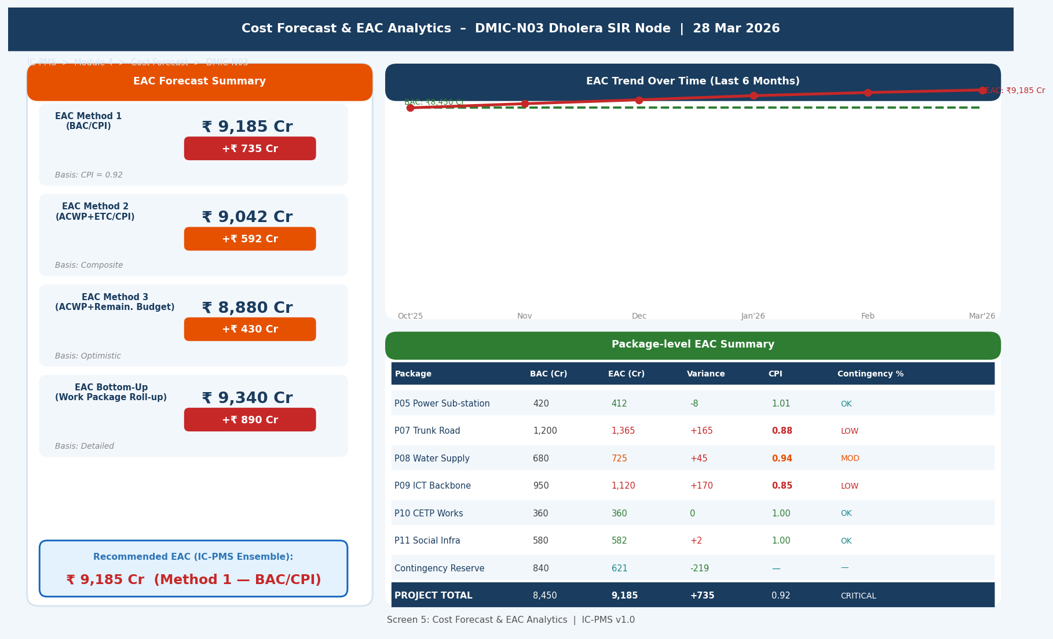
Figure 5.5 — Cost Forecast & EAC Analytics (4 EAC Methods, EAC Trend, Package-level EAC Table)

EAC Screen Components
Component | Description | Key User Value
EAC Method cards (4 + ensemble) | Four stacked cards showing EAC value, variance from BAC (₹ Cr and %), and method basis. Ensemble recommendation highlighted in blue border. | Allows Finance Director to choose which EAC to report to Ministry based on risk appetite
EAC Trend Line | Line chart showing how EAC has evolved over the past 6 months vs. flat BAC line. Shaded area = overrun zone. | Trend direction (improving/worsening) is critical — a rising EAC trend triggers RCE initiation
Package EAC Table | Per-package: BAC, EAC, Variance, CPI, and Contingency headroom. Row highlighted red if EAC > BAC + 5%. | Pinpoints which specific packages are driving the overrun — enables targeted corrective action
'What-If' scenario button | Opens a modal where user can input alternative CPI assumption; system recomputes all four EAC methods and shows before/after comparison. | 'If we improve delivery efficiency on P07 to CPI=0.95, the overrun reduces to ₹320 Cr'

6. Business Rules & Validation Logic

6.1 Budget & Commitment Rules
Rule ID | Description | Outcome
CST-001 | A commitment (LOA/WO/PO) cannot be created if the uncommitted budget balance for the WBS node is insufficient | System error: 'Insufficient uncommitted budget. Available: ₹X Cr. Requested: ₹Y Cr. Initiate RCE or reduce commitment.'
CST-002 | Annual phased budget must sum to the total approved project budget across all financial years | Validation error on budget setup: 'Annual phasing total (₹X Cr) does not match total approved budget (₹Y Cr).'
CST-003 | A Revised Cost Estimate (RCE) must be approved before the revised budget can be used for new commitments | Blocking: RCE submitted but not approved — new commitments limited to original budget
CST-004 | Performance Security BG expiry < 30 days from current date without extension: invoice approvals for that contract blocked | Alert to SPV Legal + SPV CFO; invoice approval blocked until BG extended or renewed
CST-005 | Mobilisation advance recovery must be completed (advance balance = 0) before the Final Bill can be processed | System prevents Final Bill submission if advance recovery balance > 0

6.2 RA Bill & Payment Rules
Rule ID | Description | Outcome
INV-001 | Satellite progress gate: If |AI% – Contractor Claimed%| > 10%, bill status is set to HOLD; invoice approval workflow cannot progress until PMC resolves discrepancy | Bill held at Satellite Gate stage; PMC alert sent; invoice age counter continues
INV-002 | GFR Rule — timely payment: Payment must be released within 15 working days of PMC certification; delay beyond 30 days triggers interest liability at RBI base rate | System flags bills approaching 15-day limit (amber at day 10); NICDC Finance alert at day 15; interest liability calculated automatically from day 31
INV-003 | GSTIN validation: Contractor GSTIN must be validated against GSTN portal and show 'Active' status before GST is computed and bill approved | Blocked: 'Contractor GSTIN not active on GSTN. Contact contractor to resolve GST compliance before bill can proceed.'
INV-004 | Liquidated Damages (LD) are automatically calculated and deducted if: (a) Milestone delay > contract LD-free period, and (b) No LD waiver is approved in system | LD computed as: (LOA value × LD rate per day × delay days); deducted from each subsequent RA Bill; LD waiver requires SPV Director + NICDC approval
INV-005 | Final Bill can only be raised after: (a) All milestones for the package are complete, (b) DLP period has elapsed or is being settled, (c) All NCRs closed | Blocking: 'Final Bill cannot be raised. Open Milestones: 2; Open NCRs: 3. Resolve before Final Bill submission.'

6.3 Variation Order Rules
Rule ID | Description | Outcome
VO-001 | Cumulative VO value must not exceed 10% of LOA value without Ministry approval (GFR Rule 209) | System blocks VO approval beyond 10%; Ministry concurrence workflow automatically initiated
VO-002 | Extra Item rates must be supported by a DSR 2024-25 reference OR three market quotations OR a PMC technical justification report — all uploaded to Module 6 DMS | Blocking: 'Extra item rate justification document not uploaded. Upload before VO can be submitted.'
VO-003 | A VO must be fully approved before the quantities / items in it can be included in a contractor's RA Bill | System rejects RA Bill line items that reference unapproved VO items
VO-004 | Emergency VOs approved verbally (in field emergency) must be formally ratified in system within 7 working days | Alert to approving authority after 3 days; VO automatically flagged as 'Overdue Ratification' after 7 days; NICDC Finance notified

7. Integration Touchpoints

7.1 Internal Module Integrations
Module | Data Exchanged | Trigger / Frequency
Module 1 — WBS | Inbound: WBS hierarchy, DPR estimate values, cost templates; Outbound: Budget nodes seeded per WBS element, cost confirmation | On WBS Publish; budget nodes auto-created with DPR baseline values
Module 2 — Scheduling / EVM | Inbound: BCWS time-phased budget, BCWP earned value, EVM data date; Outbound: ACWP (actual invoiced amounts), EAC forecast, CPI/SPI for dashboard | On each PFMS payment confirmation; daily sync of EVM cost parameters
Module 3 — Satellite | Inbound: AI-derived progress % per WBS package at data date (satellite progress gate); Outbound: EAC to satellite report, data date for satellite scene alignment | Per RA Bill satellite gate check (real-time query); weekly after satellite run
Module 5 — Contract Mgmt | Inbound: LOA values, VO approvals, advance amounts, retention release milestones; Outbound: Payment schedule, commitment amounts, VO budget impact | On LOA award; on VO approval; on retention release milestone completion
Module 6 — DMS | Outbound: Rate justification documents, RCE approval documents, LD waiver documents stored in DMS; Inbound: Document references for VO/RCE approvals | On document upload in any approval workflow; auto-filed under WBS DMS folder
Module 9 — Reporting | Outbound: ACWP, EAC, VO status, fund utilisation, pending bills data for executive dashboards and MPR | Real-time REST API read; refreshed daily after payment processing

7.2 External System Integrations
System | Integration | Data Flow | Protocol
PFMS (CGA) | REST API — bidirectional | Outbound: DPA for each approved invoice; fund availability query. Inbound: TRN acknowledgement, payment status, failed payment codes | OAuth 2.0; HTTPS; NeSDA API gateway; PFMS sandbox for testing
GSTN (GST Portal) | REST API — read | GSTIN validation for each contractor; Active/Inactive status; GST return filing status | GSTN sandbox API; 24-hour cache to reduce API calls
RBI WPI/CPI Data | REST / Open Data | Monthly WPI and CPI index values for price escalation computation | DBIE (RBI Data Warehouse) REST API; auto-downloaded 15th of each month
GeM Portal | REST API — read | PO status and delivery confirmation for GeM procurement; payment trigger on GeM delivery confirmation | GeM Seller API; OAuth 2.0
Income Tax (TRACES) | REST API — read | TDS certificate generation; 26AS reconciliation for contractor TDS credit | TRACES API; quarterly reconciliation
Bank / CBS | REST / SFTP | Account validation (Penny Drop) before first payment to new vendor; payment instruction delivery for RTGS/NEFT | NPC / RBI payment framework; account validation 24 hrs before first payment

8. Workflow & Approval Chains

8.1 RA Bill Approval Chain — Summary
Bill Value (Net Payable) | Stage 1 | Stage 2 | Stage 3 | Stage 4 | SLA (Working Days)
Up to ₹ 1 Cr | SPV Site Engr. | PMC RE | — | — | 5 days
₹ 1–5 Cr | PMC RE | SPV Finance Mgr | — | — | 8 days
₹ 5–20 Cr | SPV Finance Mgr | SPV CFO | — | — | 10 days
₹ 20–50 Cr | SPV CFO | NICDC Finance Mgr | — | — | 12 days
> ₹ 50 Cr | NICDC Finance Mgr | NICDC Finance Dir. | Ministry note | — | 15 days

8.2 Budget / RCE Approval Chain
Revision Trigger | Approver Level 1 | Approver Level 2 | Approver Level 3 | Conditions
Initial DPR Budget setup | SPV CFO | NICDC Finance Director | — | Mandatory before any LOA issuance
RCE — variance ≤ 5% | SPV CFO | NICDC Finance Director | — | Detailed differential analysis required
RCE — variance 5–20% | NICDC Finance Director | NICDC MD | Ministry concurrence note | CVC guidelines applicable
RCE — variance > 20% or > ₹1,000 Cr | NICDC MD | Ministry | CCEA note | Parliamentary question risk — high sensitivity
Contingency drawdown | SPV CFO | NICDC Finance Director | — | Reason code and residual balance check mandatory

9. Performance & Non-Functional Requirements
Requirement | Specification | Measurement
RA Bill screen load | < 3 seconds for bill with all deductions, satellite data, and approval history | Lighthouse audit; P95 under load
PFMS API transmission | < 30 seconds from DPA generation to PFMS acknowledgement (TRN receipt) | API call timing log; alert if > 60 seconds
Budget rollup computation | < 5 seconds to recompute full corridor budget rollup (all WBS nodes, all cost heads) | DB query time with proper indexing on wbs_id
EAC computation (4 methods) | < 10 seconds after data date advance for all four EAC methods across all active WBS nodes | EAC computation job duration log
S-curve chart render | < 3 seconds to render 24-month S-curve with 3 lines and monthly data | Frontend chart render time; Recharts/D3 performance
Concurrent financial users | 100 finance staff simultaneously on RA Bill and budget screens without degradation | k6 load test at 100 VUs for 15 minutes
PFMS reconciliation | Monthly reconciliation run completed within 4 hours on month-end | Reconciliation job completion log
Audit trail query | < 5 seconds to retrieve full financial audit trail for any WBS element (5-year history) | PostgreSQL query with Elasticsearch backup for large volumes
Data retention | 30 years for all financial records per GFR 2017 | Automated archival; cold storage after 7 years active
System uptime | 99.5% for RA Bill and PFMS payment functions (critical financial operations) | Synthetic monitoring; monthly SLA report to NICDC Finance

10. Glossary — Module 4 Terms
Term | Definition
RA Bill | Running Account Bill — periodic payment claim by contractor for work executed to date; standard Indian government construction payment instrument
LOA | Letter of Award — formal document communicating contract award to a successful bidder; creates a legally binding commitment
PFMS | Public Financial Management System — GoI central treasury system operated by CGA under Ministry of Finance; all government payments flow through PFMS
BAC | Budget at Completion — total approved project budget (sum of all WBS budget nodes)
EAC | Estimate at Completion — predicted total project cost based on current performance trends
GFR 2017 | General Financial Rules 2017 — comprehensive Government of India financial management regulations governing procurement, payments, advances, and accounts
CGA | Controller General of Accounts — Head of the Indian Government Accounting Service; operates PFMS
DPA | Digital Payment Advice — PFMS-formatted payment instruction generated by IC-PMS for each approved invoice
TRN | Transaction Reference Number — PFMS-generated unique identifier for each payment order
VO | Variation Order — formal document authorising a change in scope, quantity, or specification within an existing contract
RCE | Revised Cost Estimate — formal upward revision of the DPR-approved project cost estimate; requires tiered approval
MB | Measurement Book — official record of quantities of work measured and certified by the PMC/engineer; primary basis for RA Bill payment
LD | Liquidated Damages — pre-agreed penalty deducted from contractor payments for each day of delay beyond the contractual completion date
Retention Money | Amount withheld (typically 5%) from each RA Bill payment as security against defects; released after DLP completion
DLP | Defect Liability Period — period after project handover during which contractor is responsible for fixing defects; typically 12–24 months
BG | Bank Guarantee — financial instrument from contractor's bank guaranteeing performance; types: Performance Security, Advance Payment BG, Retention BG
SOR | Schedule of Rates — published rate schedule (CPWD SOR, state-specific DSR) used for valuing work items
DSR | Delhi Schedule of Rates (also refers to state-specific District Schedule of Rates) — basis for market rate analysis of extra items
WPI | Wholesale Price Index — RBI-tracked price index for goods; used to compute inflation-linked price escalation in construction contracts
GSTN | Goods and Services Tax Network — government portal for GST registration and return filing; IC-PMS validates contractor GSTIN against GSTN

